**PLAGIARISM STATEMENT**

I/We certify that this assignment is my/our own work, based on my/our personal study and/or research and that I/We have acknowledged all material and sources used in its preparation, whether they be books, articles, reports, lecture notes, and any other kind of document, electronic or personal communication. I also certify that this assignment has not previously been submitted for assessment in any other unit, except where specific permission has been granted from all unit coordinators involved, or at any other time in this unit, and that I have not copied in part or whole or otherwise plagiarised the work of other students and/or persons.

Name : Pranav Gupta

Signature :

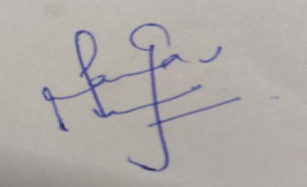

Date : 25-11-2021

Name : Hary Ahuja

Signature :

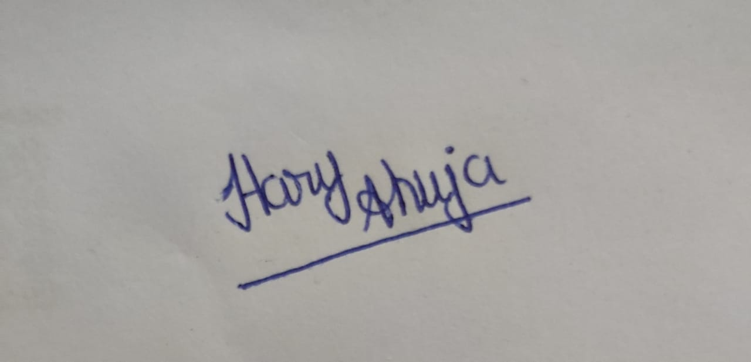

Date : 25-11-2021